
Department | FED
Subject | DSA-2
Academic Year
Faculty Name
Student Name
Roll Number
Branch
Course Outcome

Case Study Topic: Spotify Monthly-Listener Leaderboard
Work Done Summary:
- Modeled Spotify artists and their monthly listener counts.
- Implemented a Min Heap of size 5 using Java PriorityQueue.
- Inserted the first five artists directly into the heap.
- For each remaining artist, compared the listener count with the heap minimum.
- Replaced the heap root whenever a larger listener count was found.
- Maintained only the top 5 artists throughout the scan.
- Avoided sorting all artists, improving efficiency.
- Extracted and displayed the final top 5 artists in descending order of listeners.

Implementation Details:
- Created an Artist class containing artist name and listener count.
- Used a PriorityQueue as a Min Heap.
- The heap root always stores the smallest listener count among the current top 5 artists.
- While scanning:
- If heap size is less than 5, insert directly.
- Otherwise compare with heap minimum.
- Replace the minimum when a larger value is found.
- After processing all artists, converted the heap into a list.
- Sorted the result in descending order for final display.

Heap State After Each Artist

Step | Artist | Heap Contents
1 | 45 | [45]
2 | 12 | [12,45]
3 | 78 | [12,45,78]
4 | 23 | [12,23,78,45]
5 | 56 | [12,23,78,45,56]
6 | 89 | [23,45,78,56,89]
7 | 34 | [34,45,78,56,89]
8 | 67 | [45,56,78,89,67]
9 | 18 | [45,56,78,89,67]
10 | 91 | [56,67,78,89,91]
11 | 50 | [56,67,78,89,91]
12 | 39 | [56,67,78,89,91]
Final Top 5 Artists
Artist | Listeners (Millions)
Artist10 | 91
Artist6 | 89
Artist3 | 78
Artist8 | 67
Artist5 | 56

Result / Output:
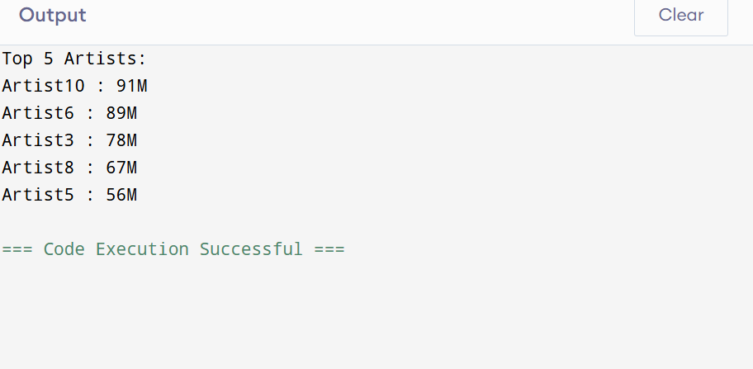
- The Min Heap successfully maintained the top 5 artists during a single scan of the dataset.
- Only artists with listener counts greater than the current heap minimum were retained.
- The final heap contained the five most-streamed artists.
- The approach avoided sorting the entire dataset and achieved a time complexity of O(n log k).
- This makes the method highly suitable for large-scale Spotify analytics involving millions of artists.

Time Complexity:
- Heap Insert: O(log k)
- Heap Delete: O(log k)
- Heap Peek: O(1)
- Top-K Search: O(n log k)
- Space: O(k)
- Heapify: O(n)
- Heapsort: O(n log n)
- Quicksort: O(n log n) average, O(n²) worst
- Merge Sort: O(n log n) with O(n) extra space

GitHub Link:
https://github.com/hemaswi2008/DSA-CO5/tree/main